**Mr Robot CTF write-up**

This is write-up for Mr Robot CTF in TryHackMe which we have to exploit web server, find a way to access target machine and elevate our privilege to rock this box

Site: <https://tryhackme.com/room/mrrobot>

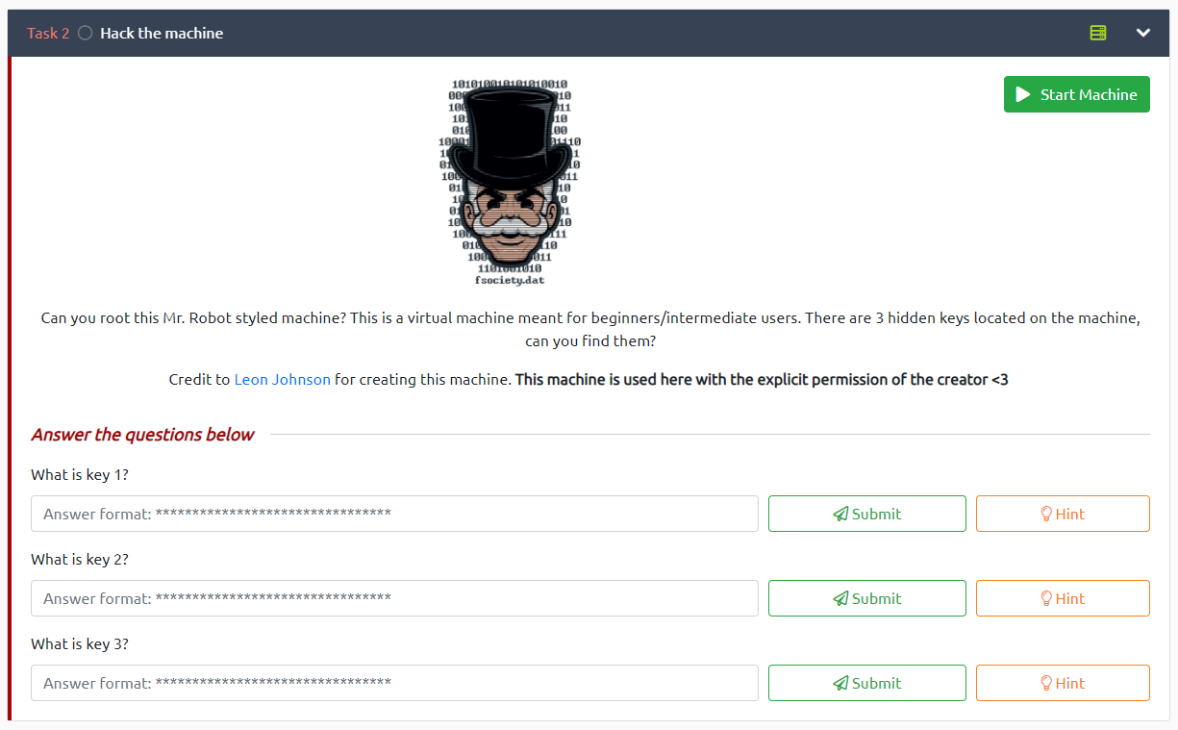

First always run nmap for port scanning and enumerate service which we see 2 ports are opened

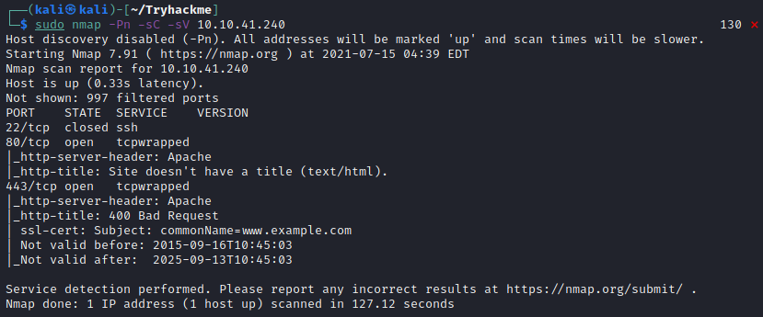

Visit the Website and it look like a Terminal-like website that will execute specify command which related to Mr Robot Series and will be redirected to 6 web page that contain video and information about fsociety

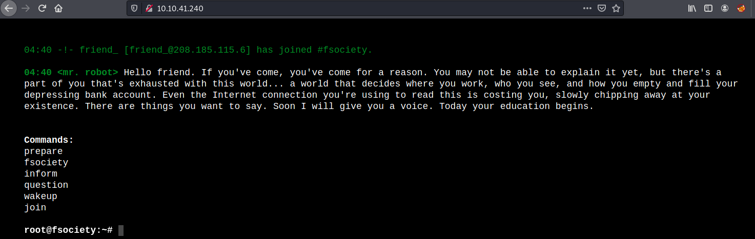

Now it’s time for gobuster to bruteforce directory after launch gobuster let’s check robots.txt and we found dictionary file and first flag

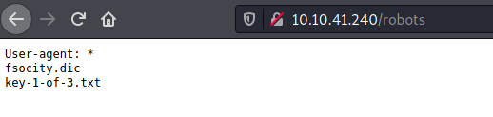

Download dictionary file and capture our first flag



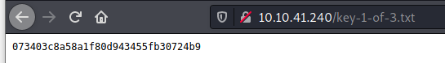



Back to gobuster, we found /0 directory

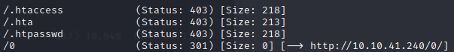

And it’s WordPress!

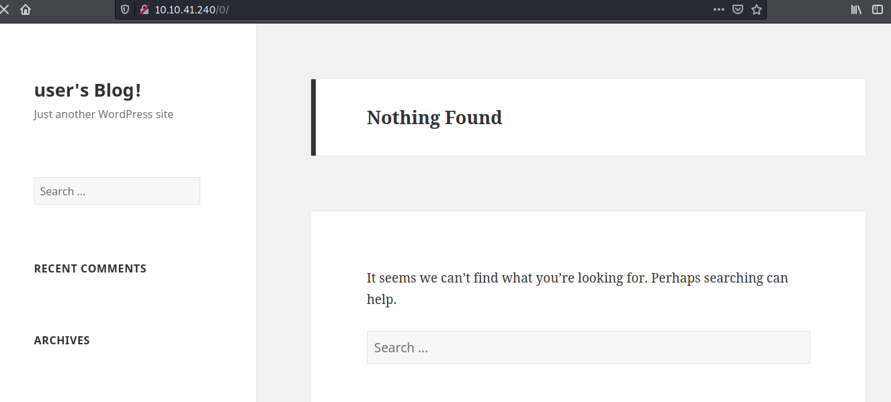

Scroll down and we can go to login page via this button or go to wp-login.php that could be a default login page for wordpress

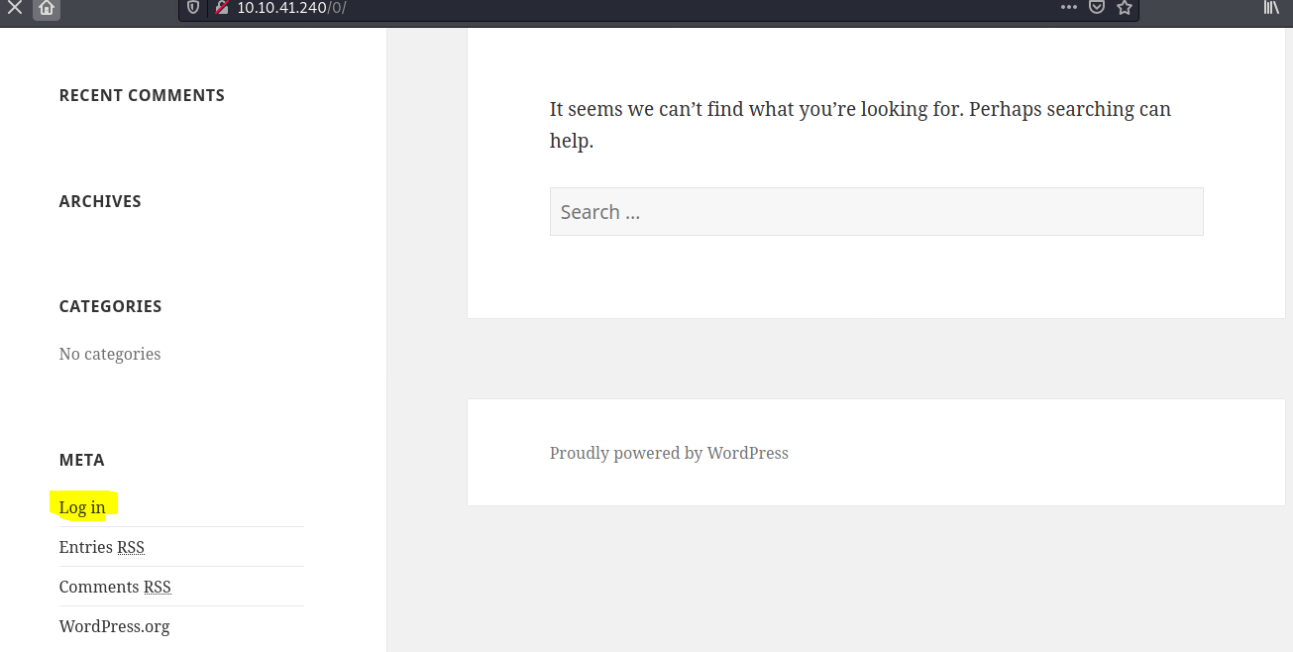

In login page we found that it has expose sensitive data after I typed Elliot as username

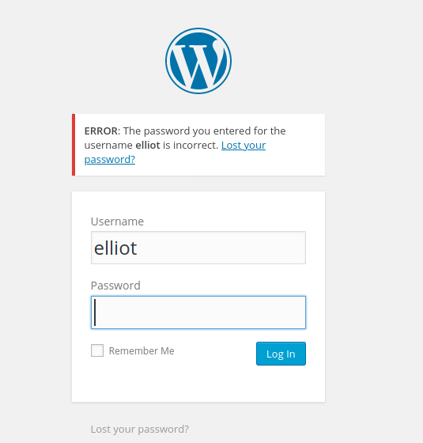

We have WPScan for WordPress scan and bruteforce password but first we need to sort and cut everything duplicate data first



Now let’s use wpscan with tag –url, --enumerate for password guessing, -U for username and –P for wordlists

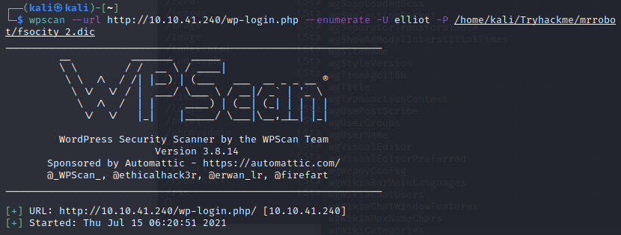

And finally we got a valid password for Elliot user

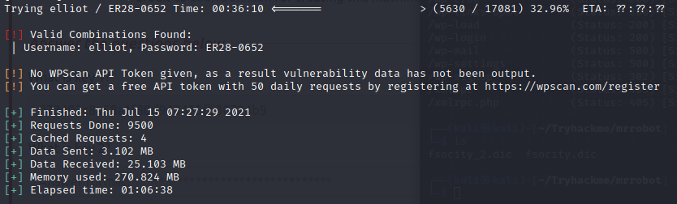

Now we can login as Elliot



After explore a little bit, we found that Mr Alderson can edit these php themes

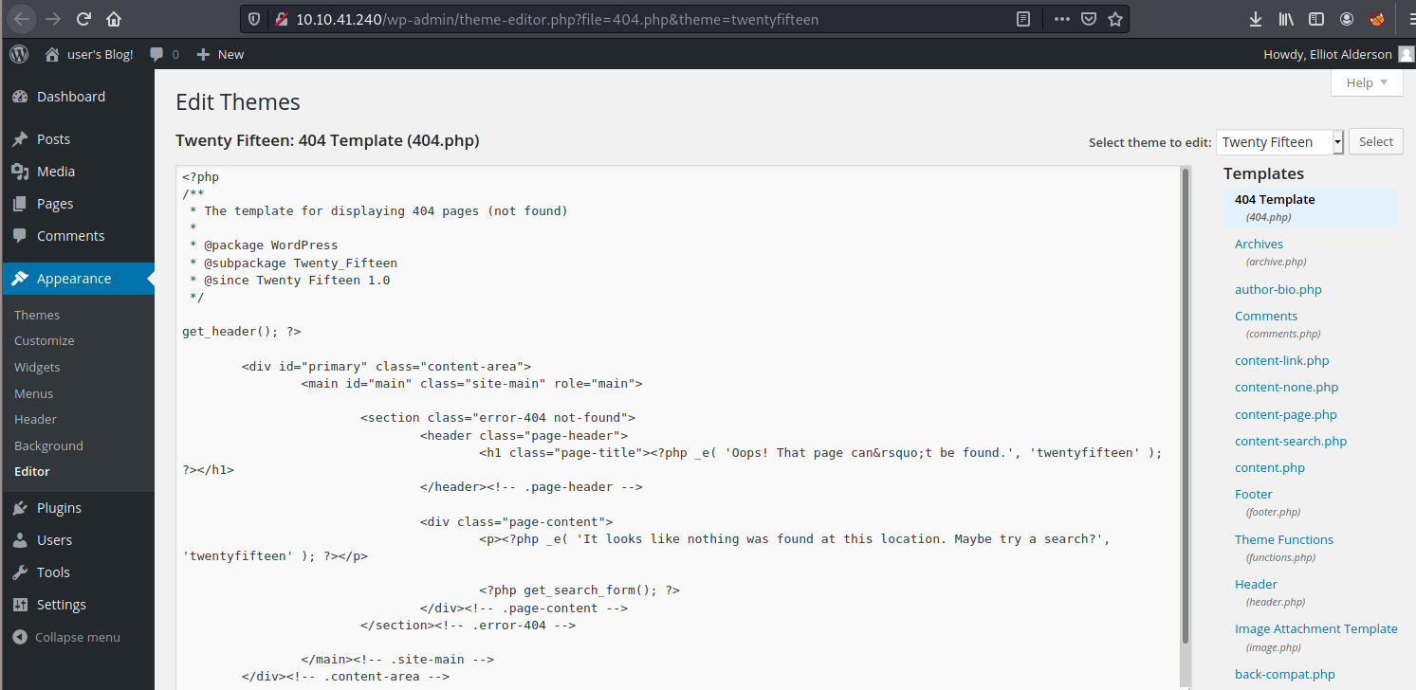

It’s time for PHP reverse shell to shine, paste php reverse shell code here and change ip and port that we will receive reverse shell

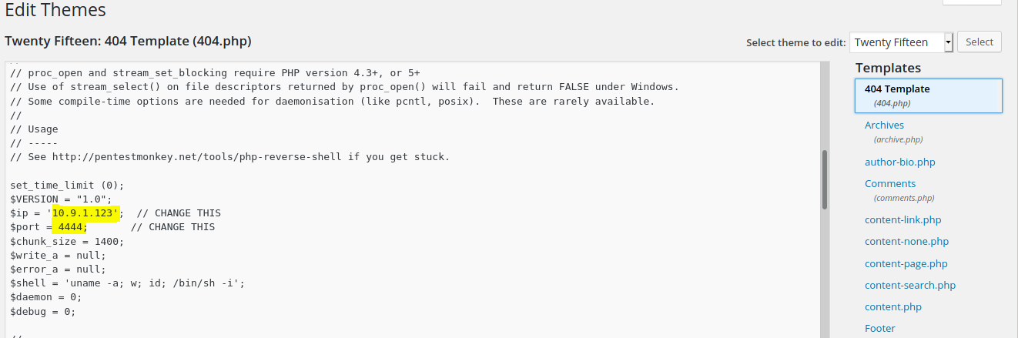

Update file

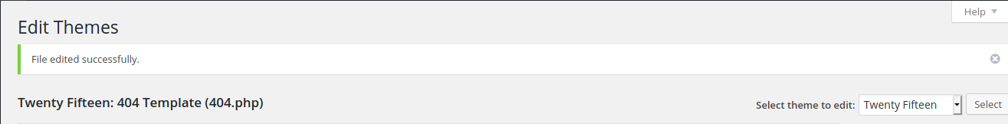

Set netcat listener and go the page that we edited for reverse shell



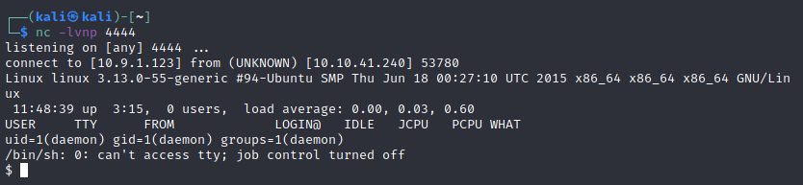

It’s time to explore file system and there is only 1 user in this box which have our second flag and password file in user directory

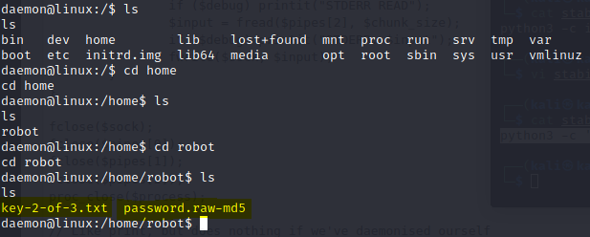

But we can’t capture this flag yet we need to be robot user first



Get password.raw-md5 file and crack it



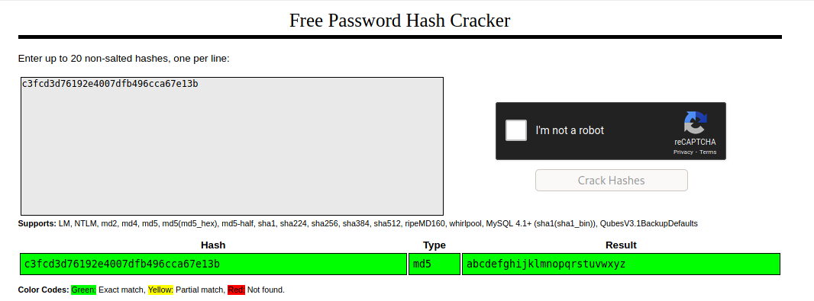

Now we can switch to user robot (we need to use stabilized shell to run command su

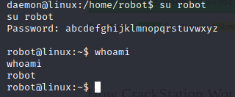

Capture our second flag





The last flag should be a root flag I tried sudo but it didn’t work so I will find executable that we can use to elevate our privilege and nmap can help us

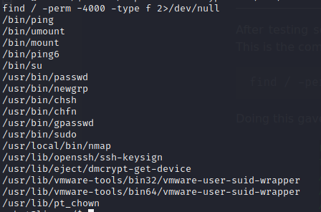

Search in GTFOBins will can see that nmap in many versions can use to spawn a shell

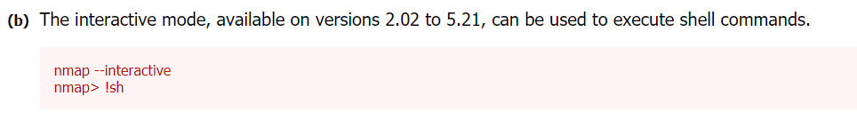

And this nmap is qualified

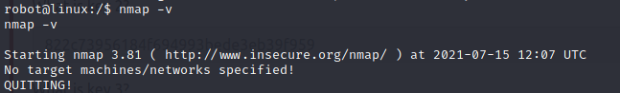

Now get our root shell

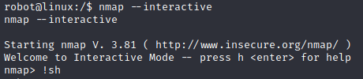

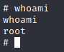

Go the root directory and capture last flag!

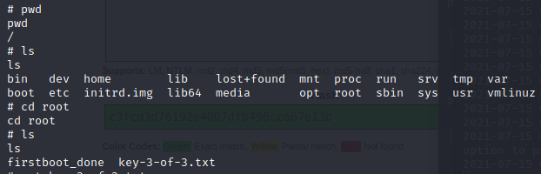





All keys have been captured!

